**CUSTOMER ANALYTICS**

**( _____ Documentation of the customer analytics data**

( In linked in I am seeing many posts that are showing like learning Business Intelligent tools is the ultimate goal for a business analyst. But I am feeling that As a business analyst ultimate goal should be resolving hurdles of the organization, and Identifying the solution hidden in the data)

**What is the data ?**

The data set having the information regarding Customers feedback Towards various aspects and Customers details of Hotel management

**Who can utilize the data?**

Managers ,Investors, Staff members

**Where is the data generated from ?**

OLTP systems, Record entries ,App ratings

**What ae the key factors of the data ?**

**.**Identifying promoter percentage

. Identifying the pain points of the customers

.Identinfying the system neglected issues

**Who are the stack holders of the data?**

Managers,investors,customers

**What your are trying to explain ?**

**What are the hidden factors this data is revealing ?**

**What is the situation do stock holders demands this data?**

Expanding the current business

Implementing the new methods in order to gain more profits

Opening the new franchises

Identifying the gap in current system

Introduction

**Problem:** In recent times data is booming everywhere and developers easily developing softwares to made the business process very easy and same way it is equally increasing the significance of the dataanalysts and business analytics everywhere, but big companies easily hire business analysts and data analysts to process the data, but medium and smll orgs not able to leaverage of this analytics because of the Cost of the process and Importantly about intelligent tools, so I focused on Excel. Excel is the tool everyone can offered, by implimenting little techniques we can build sompatible dashboards Like I have traid on Customer analytics data set.

**Overview :**This project is related to Hotel management having the relevant data captured daily entries like customer information, staff attributes,and feedbacks given by the customers for services providing in the hotel and marketing metrics. We can utilize this data to analyze pros and cons of the management and can analyse customer experience and made common recommendations basd on he customerinformation.

**Project scope:**

In this project i have focused on the techniques and tools of the MS excel to maintain and transforma the data and finally visualising the data to make easy to understand, in this project i have used hotelmanagemnt data but it is typically represents other industries aswell my theme is implementing data driven on business intelligence techniques in small business units to made the process more efficient.

Data collection and preparation

Imagine that I have collected this data from a XYZ residental hotel system records(I have collected this data from Chrome). I have made following changes

Data transforamation: Excel Power query is the powerful transformation tool, I have used this tool to merge the data from other tables and made the data handy for the process.

Data loading : After transformation of the data I have loaded in datamodel, Since datamodel feature of ms excel supporting the pwer pivot and visualization process and easy connection makings with different databases so I have used this technique.

**Summarizing :** I am using power pivot feature of ms excel to aggregate data accordingly.

Data modeling : Data modeling Due to simple tabulare data I am using snoflackes data modeling.

# First I have merged Category table and feedback table with general table by using Power query merge function

# Next in the power pivot I have connect a relation Feedback table to general table with one to many relation ship

**Key findings:**

I will working with project I have mainly concentrated on techniques, and i have followed this following.

1. Creating tables in excel and defining arrays.
2. Data transformation techniques in Excel power Query
3. Data connections and modelling techniques
4. Using power pivot for Summarising the data

**Data visualization and dashboard**

**—----------------dashboard—---------------------**

I have used Three slicers in this dash board like genderwise,yers wise,purpose type. With these slicsers we can get filtered data, for time saving i have limited to colour themes but we can use good colour combinations to maintain the dashboard more attractive. Excel having limited visuals compared to Other visualisation tools I have created a guage parameter for indicating net promoter score.

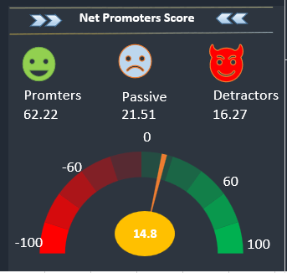

**Implementation and Impact:**

In this Project I have focused on working procedure rather on metrics, Imagine if we can use the data generated in day to day process in small and medium organisations we can definitely fing out the patterns hidden in the data it supports our decision making skills, to make cost efficient using google sheets and excel is the best method and having potential to make the decision process more accurate. We can leverage internet to learn more like this, I have practiced this project by a youtube channel [link] .

Recommendations :

We are observing that in present genera a lot of data creating every where, and profitably using this data is a boon for businesses, and even we can implement Business Intelligence free of cost with simple techniques by using Excel

Lessons learned :

While working with the data i have learned few important things

1. Creating visuals and accordingly arranging the metrics is the potential way to convey things, but in this aspect i have a little failed
2. Arranging time for this project and implementing step by step up to the completion teaches me the importance of the time management techniques.
3. I have leveraged my friends insights to understand the project in detail

Conclusion

As mentioned earlier I have focused on the process not much on the metrics side i believe if we know the process how to do it gives perfect answer why to do. My anthem is leveraging the business intelligence in business process to make the decision process more easy and accurate which is supported by the data. ____ )

**Customer data analytics**

**Problem stateement**

In today's digital landscape, the abundance of data is transforming the way businesses operate, leading to a greater demand for data analysts and business analytics professionals. While large companies have the resources to hire specialized experts to analyze their data, smaller and medium-sized organizations often struggle to capitalize on the benefits of analytics due to cost constraints and limited access to sophisticated tools. To address this issue, I have focused on leveraging the power of Microsoft Excel, a widely accessible and cost-effective solution. By implementing a few simple techniques, it is possible to create compatible dashboards, as exemplified by my work on a customer analytics dataset.

Overview

This particular project revolves around hotel management, encompassing the collection of relevant data through daily entries. The data includes customer information, staff attributes, feedback provided by customers regarding the services offered by the hotel, as well as marketing metrics. By utilizing this data, we can conduct a comprehensive analysis of the hotel's strengths and weaknesses, evaluate the overall customer experience, and generate practical recommendations based on the customer information gathered.

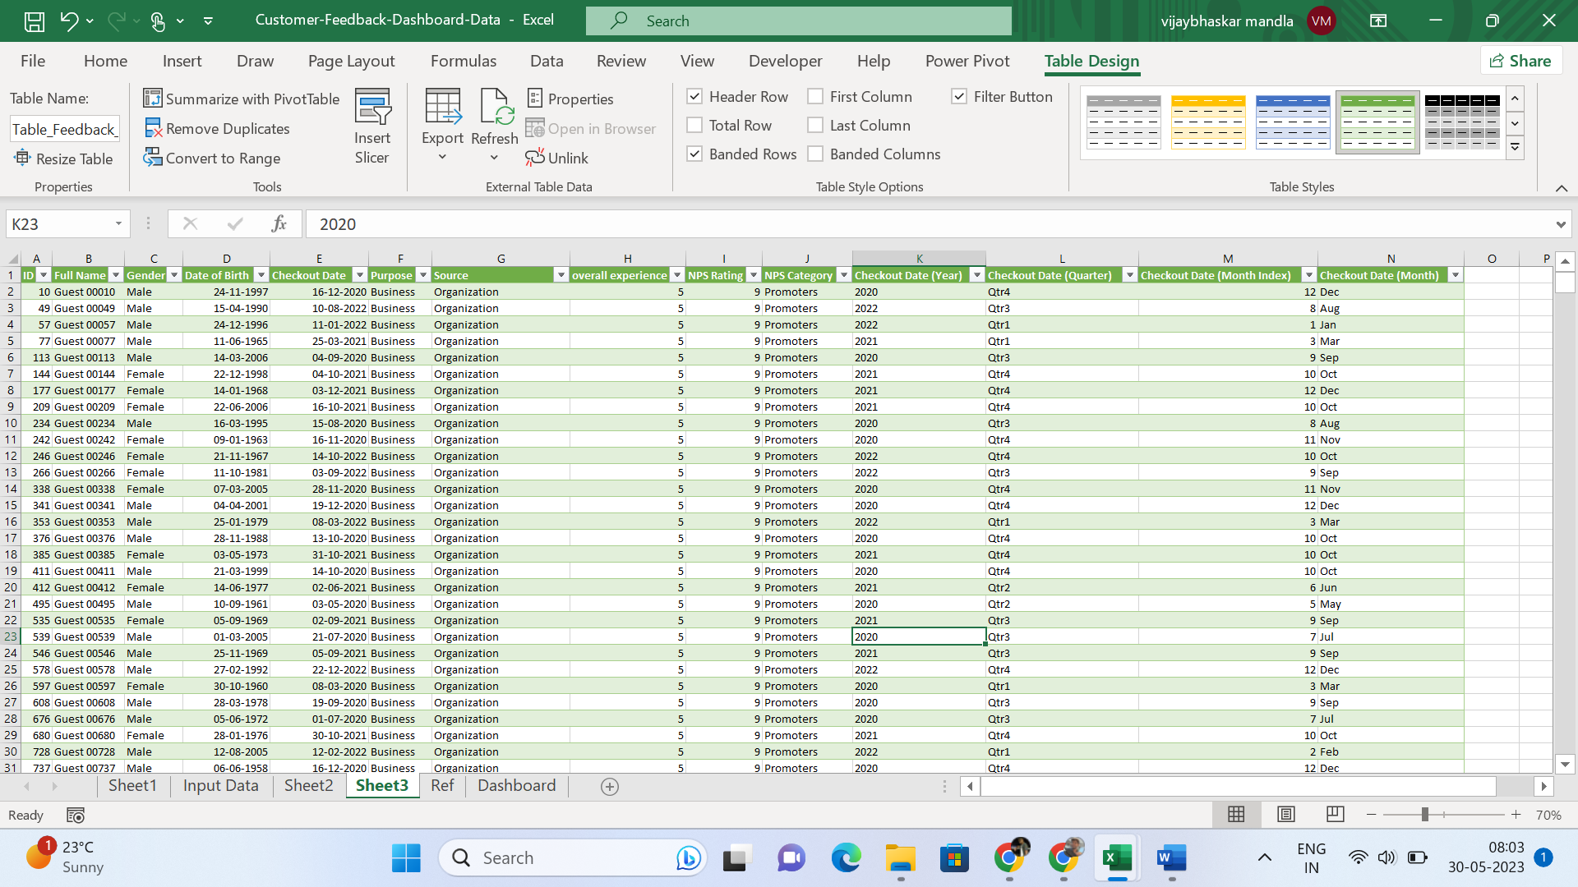

Project scope

This project primarily revolves around leveraging the techniques and tools offered by MS Excel to effectively manage and transform data, ultimately enabling the visualization of data in a user-friendly manner. While the project employs hotel management data, the techniques employed can be applied across various industries. The main objective is to implement data-driven business intelligence techniques in small business units, aiming to enhance operational efficiency and streamline processes.

Data collection and preparation:

I have obtained the data for this project from the records of XYZ Residential Hotel system, collected through the Chrome browser. In order to facilitate the data processing, I have employed Excel Power Query, a powerful transformation tool. Using this tool, I merged data from various tables and structured it in a more accessible format.

After transforming the data, I loaded it into a data model within Excel. Leveraging the data model feature, I was able to utilize Power Pivot and facilitate data visualization. This feature also allowed for easy connections with different databases, enhancing the overall data analysis process.

For summarizing the data, I utilized the capabilities of Power Pivot to aggregate the information as per the requirements of the analysis.

In terms of data modeling, given the simplicity of the tabular data, I opted for a snowflake data modeling approach. Firstly, I merged the Category table and Feedback table with the General table using the Power Query merge function. Subsequently, in Power Pivot, I established a relationship between the Feedback table and the General table, utilizing a one-to-many relationship.

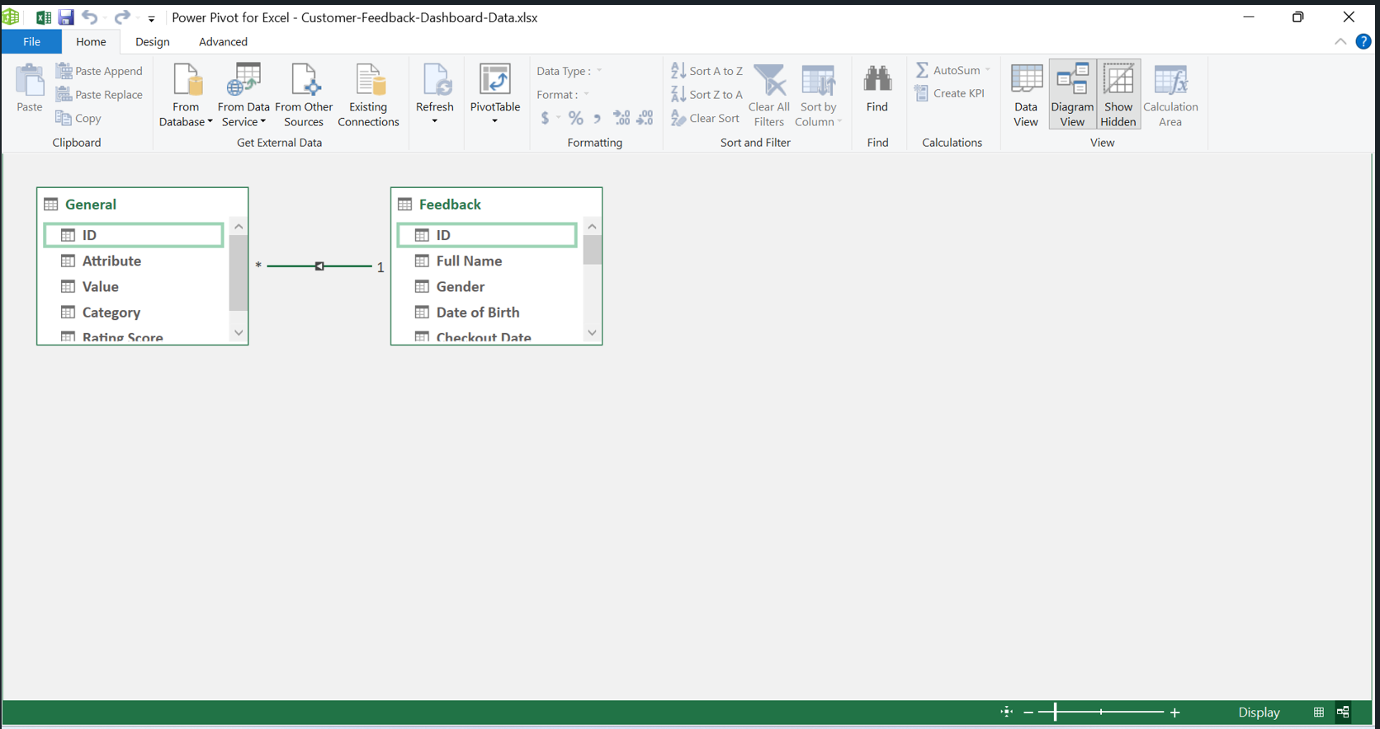

Key Findings

In the project I've been working on, I focused on various techniques. Here are the specific areas I concentrated on:

1. I utilized Excel to create tables and define arrays.
2. I employed data transformation techniques using Excel Power Query.
3. I utilized data connections and modeling techniques.
4. I leveraged Power Pivot to summarize the data effectively.

Data visualization and dashboard.

In this dashboard, I incorporated three slicers: one for gender, another for years, and the third for purpose type. These slicers allow us to filter the data and save time. Although Excel has limited visuals compared to other visualization tools, I made use of color themes to maintain an attractive dashboard. Additionally, I included a gauge parameter to indicate the Net Promoter Score, which serves as a visual representation.

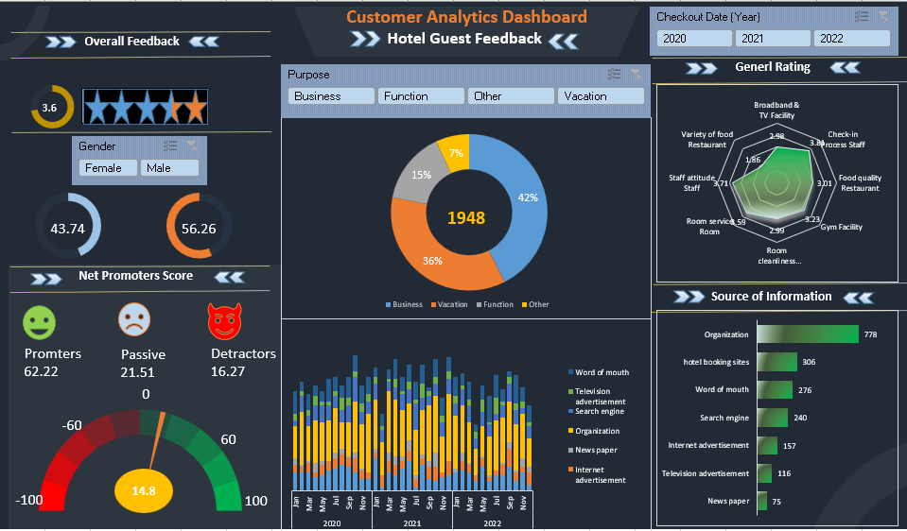

**Implementation and impact:**

In this project, my main focus was on the working procedure rather than specific metrics. I believe that in small and medium organizations, utilizing the data generated in day-to-day processes can reveal hidden patterns and greatly enhance our decision-making abilities. To ensure cost-efficiency, leveraging Google Sheets and Excel is the most effective method, as it has the potential to improve the accuracy of the decision-making process. Moreover, we can utilize the internet as a valuable resource for further learning in this area. I practiced the techniques used in this project through a YouTube channel, which you can find at [link].

Recommendations :

In today's generation, we are witnessing a massive amount of data being generated across various sources. Effectively harnessing this data can prove to be extremely beneficial for businesses. Surprisingly, we can implement Business Intelligence using simple techniques without incurring any costs by utilizing Excel.

Lessons learned:

During my work with the data, I gained several important insights. I discovered that creating visuals and organizing metrics appropriately is a powerful way to effectively communicate information. However, I must admit that I encountered some challenges in this aspect. Managing time and implementing the project step by step until completion taught me valuable lessons about the importance of time management techniques. Additionally, I greatly benefited from the insights shared by my friends, which helped me gain a deeper understanding of the project.

Conclusion.

Based on the information provided, it can be concluded that the project primarily emphasized understanding and implementing the process rather than focusing heavily on specific metrics. The belief was that knowing the "how" of a process leads to a better understanding of the "why." The project's underlying objective was to leverage business intelligence within business processes to simplify and improve the decision-making process. By utilizing data effectively, the aim was to make informed decisions that are both easier and more accurate. The project highlighted the importance of techniques and tools like Excel in achieving this goal. Overall, the project's focus on process knowledge and the integration of business intelligence demonstrated a commitment to enhancing decision-making through data-driven insights.